**Assignment 06**

**Q 01: This question is from FileSystem. Answer each part below individually:**

1. Suppose the size of a file is 3 GBytes. You are required to find out how it is possible to allocate blocks using contiguous, linked, and indexed allocation methods. Assume any block size (512 Bytes, 1024 Bytes or any other). Furthermore, using indexed allocation use any scheme you want (linked scheme or multilevel indexing). Remember the goal would be to use the least number of blocks. Draw diagrams with each method you use. The diagram should depict the exact number of blocks and types of blocks you use and not a generic block diagram.
2. In part two of this question, you are required to discuss the pros and cons of each methods you used. Finally, choose one method and/or scheme that you think will be best suited for the machine you are currently using.

**Q02: This question is from Memory Management.**

You have to write a function that checks whether it is necessary to load a page from the backing store or not. If necessary, the function loads the page from the backing store and updates the page table accordingly. You have to use the following functions to implement the solution:

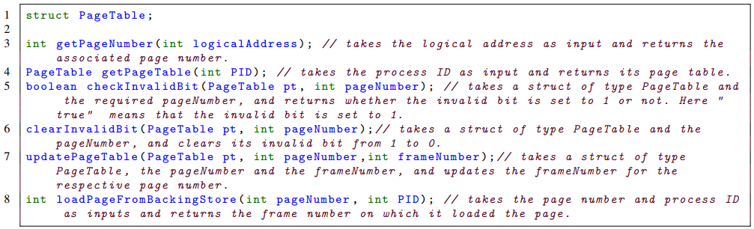

Populate your solution according to the format below:

**void** **handlePageFault**(**int** **logicalAddress**, **int** **PID**){

//your function code goes here.

}

**Q 03: This question is from Virtual Memory. Answer each part below individually:**

1. Draw a diagram that depicts how the system will behave when you create a new process using fork() vs a new process created using vfork() system calls. Explain briefly in words your diagram and the complete process and the difference between each method better for understanding. Your diagram should include the existing process address space along with the address space of the newly created (child) process.
2. Name and briefly explain the techniques that can enable the feature of Virtual Memory in a computer system. Describe the role of each technique and how these techniques are related to each other.
3. Explain the two terms “zero-fill-on-demand” and “zero’ing-out” a page.
4. Consider the two-dimensional array A:

int A[][] = new int[100][100];

where A[0][0] is at location 200, in a paged memory system with pages of size 200 bytes. Each int type needs 4 bytes and A is stored in row-major order (as in C/C++). A small process is in page 0 (locations 0 to 199) for manipulating the array; thus, every instruction fetch will be from page 0. For three-page frames, how many page faults are generated by the following array initialization loops, using LRU replacement, and assuming frame 0 has the process in it and the other two frames are initially empty?

* 1. for (int j=0; j < 100; j++)

for (int i=0; i< 100; i++)

A[i][j]=0;

* 1. for (int i=0; i< 100; i++)

for (int j=0; j < 100; j++)

A[i][j]=0;

**Instructions:**

* You are required to submit **a single PDF** document and submit the quiz **before 1.00 PM on Wednesday, 23rd** via google classroom.
* All text should be in digital form except for diagrams that can optionally be hand-drawn. Remember to add the snaps of hand-drawn diagrams to the submitted single pdf document.
* Be brief, concise and clear in your answer. DO NOT write long stories.
* In case of ambiguities, take proper assumptions to answer the question.
* Plagiarism will be strictly dealt with and will result in 0 score.